**HW1: Data Exploration and Preparation**

**Goal**

This exercise is the first of three mini-projects to help you stop the spread of disease globally. We present the **Virus Test Challenge Dataset (VTC)** with labeled patient data. Your goal is to understand and prepare this dataset for prediction. While we will soon learn several methods for training prediction models, none of them will work without us first understanding and cleaning our data. So, in this exercise, we will perform standard data preparation practices to identify regularities and irregularities in the data.

**Good Luck!**

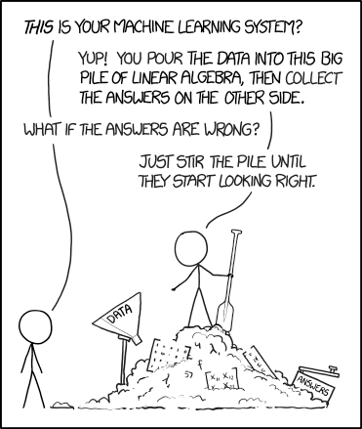

Source: [xkcd](https://xkcd.com/1838/)

**Instructions**

* **Submission**
  + Submit by Tuesday,02.07.24 (23:59) in groups of 2 students.
  + Submitted to the webcourse.
* **Python environments and more**
  + We recommend using jupyter notebooks. [Google colab](https://colab.research.google.com/) can be very convenient since it does not require installing anything on your local computer. It will also help you to collaborate with your partner online.
  + Initial notebook [here](https://colab.research.google.com/drive/1k4-_0ZUmM_1lFUyWvaEBF6GoT93I38VY?usp=sharing).
    - Demonstrates how to upload a dataset to Google colab and how to download files from Google colab.
    - You can save a copy of this notebook to your Google drive.
  + However, you are allowed to use any Python IDE you choose. For working locally with an IDE, we recommend first installing [conda](https://docs.conda.io/) for package management (with Python 3.6 or 3.8), and then installing an IDE like [PyCharm](https://www.jetbrains.com/pycharm/download/) or [Spyder](https://www.spyder-ide.org/).
* **Your code**
  + Should be clearly and briefly documented.
  + Variables/classes/functions should have meaningful names.
  + May be partially reviewed and graded (בדיקה מדגמית).
* **Final report**
  + Should be written in a word processor (Office Word, Google docs, etc.).
    - Should not contain the code itself. Do not submit jupyter notebooks as PDFs.
  + Can be in Hebrew, English, or both.
  + **You are primarily assessed based on your written report.**
    - Will be partially reviewed and graded (בדיקה מדגמית).
  + Answer the questions in this instruction file according to their numbering.
  + Add concise explanations, figures (outputs of your code), tables, etc.
  + Tables should include feature names and suitable titles.
  + Plots:
    - Must be clear, readable, and coherent.
    - Should have suitable titles, axis labels, and legends (if needed).
    - Should have [grid](https://matplotlib.org/stable/api/_as_gen/matplotlib.pyplot.grid.html) lines (except maybe heatmaps).
    - We recommend adjusting the default font sizes of matplotlib at the beginning of your notebook. You can use the following code snippet:

from matplotlib import pylab

params = {'xtick.labelsize': 18,

          'ytick.labelsize': 18,

          'axes.titlesize' : 22,

          'axes.labelsize' : 20,

          'legend.fontsize': 18,

          'legend.title_fontsize': 22,

          'figure.titlesize': 24 }

pylab.rcParams.update(params)

* + You are evaluated for your answers but also for readability, clarity, and aesthetics.
* **Submit a zip file containing** (please use hyphens, not underscores):
  + Define *<filename>* as your dash-separated IDs, i.e., *id1*-*id2* or *id1*-*id2*-*id3.*
  + The zip file’s name should be *<filename>.zip* (e.g., *123456789-200002211.zip*).
  + **Only one group member should submit the assignment to the webcourse!**
  + The report PDF file with all your answers (but not your code!), named *<filename>.pdf*.
  + Your code (choose the relevant options for you):
    - Working with jupyter: your notebook, *<filename>.ipynb*.
    - Your completed kNN module (=class) from Part 2, *kNN.py*
    - Working with a “traditional” IDE: one clear main script, *<filename>.py*,   
      and any additional files required for running the main script.
    - Data preparation function *prepare.py* (from Part 6).
  + Do not submit csv files.
* **Failing to follow any of the instructions above will lead to point deduction!**

**Part 1: Data Loading and First Look**

The VTC dataset, available on the course website as virus_data.csv, should be loaded and explored using the [pandas](https://pandas.pydata.org/docs/) library. It contains features relevant to our prediction tasks, along with ground-truth labels for our target variables: **spread** (potential to spread COVID-19) and **risk** (risk of serious illness). All your decisions in the data preparation process should be made with these targets in mind.

Unfortunately, as with any real-world dataset, VTC includes many redundancies and noise. Throughout this exercise, we will work to minimize these issues. Note: The dataset is synthetic and may not match real-world statistics.

1. Load the dataset into a Pandas DataFrame.

**Answer** (in your report)**:** how many rows and columns are in the dataset?

Before we continue, let us define the “ordinal” variable type. Ordinal variables are categorical with a natural order (e.g., year of birth), and are somewhere between continuous and categorical variables.

1. Print the value_counts of the conversations_per_day feature (see Tutorial 01).   
   Copy the obtained output to your report. Describe in one short sentence what you think this feature refers to in the real world.

This feature’s type is “ordinal”. Explain briefly why.

Remember to clearly write the number of the question next to your answer.

1. In your report, write a table describing each feature. The columns must be:
   1. Feature name: the name of the feature as it is written in the dataset.
   2. Description: a short sentence with your understanding of the feature’s meaning in the real world.
   3. Type: Continuous, Categorical, Ordinal, or Other.

Don’t overthink this (especially the “ordinal” type), some variable may be suitable for two types.

Note: do not include the target columns (“spread” and “risk”).

**Partitioning the data**

During the learning process, we measure our models’ performance on two disjoint sets: **training** and **test**. A training set is a subset of the dataset from which the machine learning algorithm learns relationships between features and target variables. The test set provides a final estimate of the machine learning model’s performance after it has been trained. Test sets should never be used to make decisions about which algorithms to use or for improving or tuning algorithms.

We will explore why this data partitioning is important later in the course, but for now, the most important thing to remember is that **you may only use the training set** for making decisions about the data, training our models, plotting graphs regarding our data, and deciding how to normalize features. The training set will help us understand what pre-processing steps we need to use on the data. **You should then apply those pre-processing steps to both the training and the test set.**

Note: later in the course, we will use another data subset, called the validation set.

1. [Split](https://scikit-learn.org/stable/modules/generated/sklearn.model_selection.train_test_split.html) the data randomly into a training set (80% of the data) and a test set (20% of the data). As the random_state, use the sum of the last two digits of each of your IDs[1] (two or three IDs).

The random state will ensure that you get the same split every time.   
Answer: Why is it important that we use the exact same split for all our analyses?

Note: it could be easier for you to answer this question after you complete the rest of the assignment.

**Part 2: Missing Values**

We will start with basic checks of our datasets, focusing on missing values, which are a common issue in machine learning. Missing values refer to data points that are absent in a specific column, often represented as null values. They pose a significant challenge in data analysis and can lead to inaccurate or biased results. Data can be missing due to technical issues, human errors, privacy concerns, and more.

1. For **both the training set and test set**, report which fields have missing values and how many missing values there are. You can use Panda's function [isnull()](https://pandas.pydata.org/docs/reference/api/pandas.isnull.html).

Another term we will use is "Outliers". There are many ways to define outliers; here, we refer to them as data points that significantly deviate from the rest of the data. Note that we won't solve the outliers issue in this section, only the missing values issue.

1. Plot a histogram (see Tutorial 01) for each field where you found missing values in **‎(Q5)**. Add these plots to your report. Answer: Can you recognize outliers?

**Reminder:** Create plots using only the training set.

There are many ways of dealing with missing values. We will consider two of them:

* 1. Calculate this field's **mean** value in the train set and use it to replace the missing values in both the train and test set.
  2. Like (a), but using the **median** instead of the mean.

1. For each field where you found missing values, calculate the median and the mean in the training set, **and report it**.

If there is a significant difference between the mean and median values, explain the reason. Which filling method do you prefer to use in our case, and why?

**Task A:** Use the method you chose to fill the missing values in **both training and test sets**. You can use Panda's function [fillna()](https://pandas.pydata.org/docs/reference/api/pandas.DataFrame.fillna.html).

**Part 3: Warming up with k-Nearest Neighbors**

In this part, we focus on the spread target variable and start with one of the simplest models we know, “k-Nearest Neighbors”.

**Reminder:** we use only the training set for now.

**Basic data exploration**

Our medical experts suspect that it is possible to predict the spread using a pair of PCR features from the set: {PCR_04 , PCR_07 , PCR_09}.

**Task B:** For each possible pair from this set, create a [seaborn.pairplot](https://seaborn.pydata.org/generated/seaborn.pairplot.html) of the two aforementioned PCR features. Use the hue parameter to color the different (train) data points according to their spread. Do not attach all these figures in your report.

Following is a code snippet that can help you start, and an example of the resulting figure (with different data):

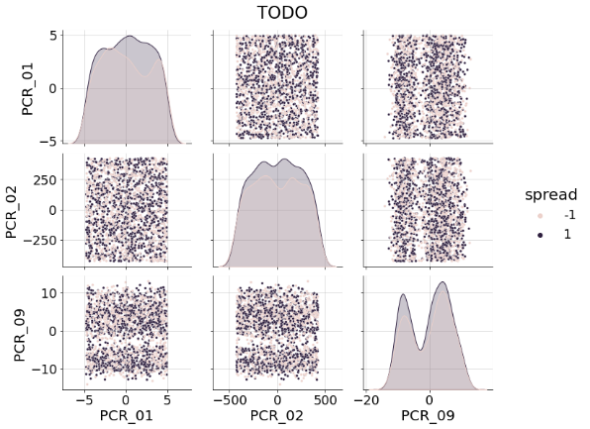

g=sns.pairplot(TODO, plot_kws={"s": 12})

g.fig.suptitle("TODO", y=1.04)

for ax in np.ravel(g.axes):

  ax.grid(alpha=0.5)

g.fig.set_size_inches(12,8)

1. Answer briefly: Based on the plots you created on **(Task B)**, what pair of features is useful for predicting the spread?

Attach the [seaborn.pairplot](https://seaborn.pydata.org/generated/seaborn.pairplot.html) of only this pair of features to the report. Make sure your plots are readable and clear, and that they have proper titles, grid lines, axis labels, etc. Any missing requirement will lead to a points deduction!

**k-NN implementation**

Our first step is to implement a basic k-NN classifier. We will inherit the BaseEstimator class from sklearn for compatibility with scikit-learn API. We will also inherit ClassifierMixin which will automatically add accuracy scoring function to our model.

**Task C:** Implement k-NN using the code template below (don’t change method signatures):

from sklearn.base import BaseEstimator,ClassifierMixin

class kNN(BaseEstimator, ClassifierMixin):

def __init__(self, n_neighbors:int = 3):

self.n_neighbors = n_neighbors

def fit(self, X, y):

# TODO: complete

return self

def predict(self, X):

# Note: You can use self.n_neighbors here

predictions = None

# TODO: compute the predicted labels (+1 or -1)

return predictions

Avoid using for loops, list, map, lambda, etc.

**Tip:** Read about [scipy…cdist](https://docs.scipy.org/doc/scipy/reference/generated/scipy.spatial.distance.cdist.html), [np.copy](https://numpy.org/doc/stable/reference/generated/numpy.copy.html), [np.argsort](https://numpy.org/doc/stable/reference/generated/numpy.argsort.html) (or better: np.argpartition [[1]](https://stackoverflow.com/a/34226816/1947677),[[2]](https://stackoverflow.com/questions/26322232/how-to-apply-the-output-of-numpy-argpartition-for-2-d-arrays)).

1. What is the time complexity of the prediction function you wrote, applied on a single test datapoint, in terms of the number of neighbors $k$, the number of training   
   datapoints $m$ and the data dimension $d$? Explain. It is okay to “estimate” the complexity of python library functions. For instance, if you use np.argsort on $n$ elements, then its complexity should be $O\left(nloglog n \right)$. Use your reason and CS knowledge.

We will now test your implementation.

**Task D:** Create a temporary DataFrame by taking only the two features you chose on **‎(Q8)** from the training set. Train a 1-NN model (with k=1) on this subset to fit the spread label. Use the provided visualize_clf function to visualize the decision regions of the model (send only the training set to this function, so that only the training examples will be scattered on the plot).

Compute the training accuracy and test accuracy of the model by calling its   
score method, e.g., call h.score(Xtrain, Ytrain).

Make sure that all labels in your notebook (the ones in the dataset and the ones your model return) are $±1$, and not $\left\{0,1\right\}$ or $\left\{True,False\right\}$.

1. Attach the figure to your report. Specify the model’s training and test accuracies.

(The plot should exhibit a bizarre behavior which we will discuss next.)

**Data Normalization**

In machine learning, it is common to normalize the features, as this allows us to develop better models (we will see soon why). We now focus on two normalization techniques: [Standardization (Z-score)](https://en.wikipedia.org/wiki/Feature_scaling#Standardization_.28Z-score_Normalization.29) and [min-max scaling](https://en.wikipedia.org/wiki/Feature_scaling#Rescaling_.28min-max_normalization.29) (read the explanations in the links). Implementations can be found [here](https://scikit-learn.org/stable/modules/generated/sklearn.preprocessing.StandardScaler.html) and [here](https://scikit-learn.org/stable/modules/generated/sklearn.preprocessing.MinMaxScaler.html).

Notice: we often ask questions in the exams regarding reading materials that appear in the assignments.

1. Use min-max scaling (between $\left[-1,1\right]$) to normalize the two features in the temporary DataFrame you created before, and train a new kNN model ($k=1$) on the normalized dataset.

Compute the new training and test accuracies and draw the decision regions of the model. Attach the results to your report and compare them to those from **‎(Q10)** for the same $k=1$ model on the raw data. Use these results to explain why normalization is important for nearest neighbor models.

1. Using the normalized dataset, train another kNN model with $k= 5$. Compute the training and test accuracy and draw the decision regions of this model.

Attach the results to your report and compare them to those from ‎**(Q11)**.   
Use these results to briefly explain the effect of $k$ on the decision regions.

1. This question is general and does not deal with the given dataset. Assume a dataset with two features, one randomly sampled (i.i.d.) from a uniform continuous distribution on the range $\left[2,5\right]$ and the other randomly sampled (i.i.d.)   
   from a chi-squared distribution $χ^{2}\left(k=2\right)$ (see in [Wikipedia](https://en.wikipedia.org/wiki/Chi-squared_distribution)).

(The labels are determined by some unknown function of these two features.)

Why is normalizing both features using min-max scaling to $\left[-1,1\right]$ a bad idea?   
Explain in detail.

**Part 4: Data Exploration**

We are now ready to start the preprocessing stage for the rest of the features!

Our medical experts suggest that blood types affect the risk target variable. They propose merging blood types into two groups: {O+, B+} and {O-, A-, A+, B-, AB+, AB-}. That is, instead of having a separate Boolean feature for each blood type, we would have one Boolean feature for these groups.

**Task E:** According to the suggested groups, create a new Boolean feature called SpecialProperty in your DataFrame, indicating whether the specific data point has a blood type in {O+, B+} or not. Then, remove the original blood_type feature from the DataFrame.

Technical: You can use the following snippet as a starting point to create a Boolean series according to a subset of the values of a feature:

df["blood_type"].isin(["O+", "B+"])

**Univariate Analysis**

You will now carry out most of the univariate analysis in your notebook (or IDE).   
**You should not** add all the plots to the report, only the ones we specifically request.

For every **numerical** feature (including extracted ones), plot two histograms, one for each target variable (risk and spread), using hue to split by the target variable's value (e.g., high/low spread value). For continuous/ordinal features you should use the kde keyword to draw the estimated distribution curve (see Tutorial 01).

The following code snippet generates a 2-column figure of histograms of the features in the COL_NAME list. You may use this as a template to generate meaningful plots.  
Refer to the [seaborn](https://seaborn.pydata.org/generated/seaborn.histplot.html) documentation to understand more on histplot’s keyword arguments.

COL_NAME = ['PCR_01', 'num_of_siblings']

COLS, ROWS = (2, len(COL_NAME))

plt.figure(figsize=(5 * COLS, 4 * ROWS))

for row in range(ROWS):

  column = COL_NAME[row]

  for j, cls in enumerate(["risk", "spread"]):

    plt.subplot(ROWS,COLS, row * COLS + 1 + j)

    isContinuous = "float" in df[column].dtype.name

    sns.histplot(data=df, x=column, hue=cls, line_kws={"linewidth": 3},

                 kde=isContinuous, multiple="layer" if isContinuous else "dodge")

    plt.grid(alpha=0.5)

plt.tight_layout()

**To clarify**: in your jupyter notebook you should generate 2 histograms for every feature.   
Each histogram corresponds to one target feature (risk, spread), where the different labels are counted separately and colored differently. Continuous variable histograms should also have estimated distribution curves (using the kde argument).

1. According to the univariate analysis, name one feature that seems informative for predicting the spread target variable (other than the 2 features from **Q8**).

Attach the appropriate univariate plot and briefly explain (2-3 sentences) why this plot makes you think that feature is informative.

1. According to the univariate analysis, name one feature that seems informative for predicting the risk target variable (other than the blood groups).

Attach the appropriate univariate plot and briefly explain (2-3 sentences) why this plot makes you think that feature is informative.

**Bivariate Analysis**

We will now perform some bivariate analysis.

The following snippet performs basic bivariate analysis for the PCR features, conditioned on the risk variable. This snippet is a good reference for the next question.

sns.pairplot(df[df.filter(like='PCR').columns.tolist() + ["risk"]],  plot_kws={"s": 3}, hue="risk")

Our medical experts believe that it is possible to predict the risk using a pair of PCR features from the set: {PCR_01, PCR_03 , PCR_05 , PCR_10}, **but only after splitting the data according to blood groups.**

1. Split the (training) data based on the binary SpecialProperty feature created in **(Task E)**. For each split, perform a bivariate analysis for the PCR features in the set**,** in relation to the risk. This means you should produce two “matrices” of plots, one for each blood group. Each matrix should contain 4x4 subplots, representing all possible pairs of PCR features in the set. Do not include these plots in your report.

According to those plots, choose a pair of PCRfeatures that couldbe helpful   
for predicting the risk (with the partition according to the SpecialProperty).   
What PCR features did you choose? And why?

1. For the pair of PCRfeatures you chose in **(Q16)**, create three jointplots (see Tutorial 01), all conditioned on the risk variable. The first jointplot should include only the data in the first blood group you created in **(Task E)**, {O+, B+}. The second jointplot should include only the data in the other blood group. The third jointplotshould be for the full data, without partitioning to blood groups.

Attach the 3 resulting plots to your report. Remember to have grids, titles, and axis-labels.

Example (for one hypothetic pair):

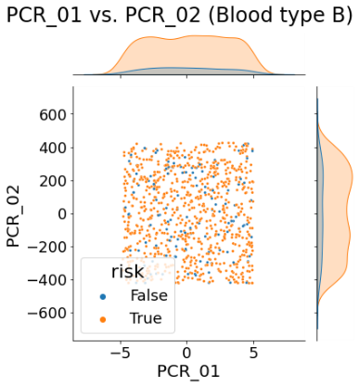

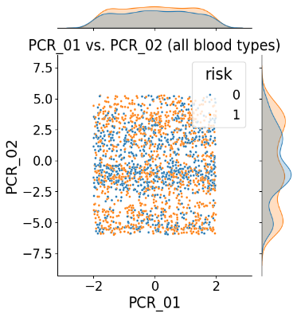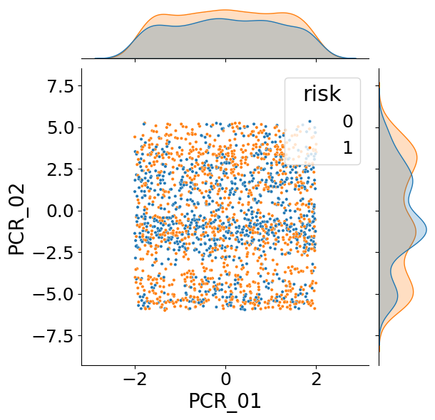

Notice that the three plots above here do not look informative for predicting the risk in any of the blood groups (look at the marginal distributions for instance).

**The risk target feature**

The following snippet demonstrates a call to the provided plot3d function:

plot3d(df, "PCR_01", "SpecialProperty", "PCR_02", title="TODO", hue="risk", s=5)

1. Use the provided function plot3d to plot the pair of PCRfeatures you chose (axes X and Z) and the SpecialProperty feature (axis Y), colored by the risk label. Make sure that the plot is clear & readable and that it has a proper title. Attach the plot to your report.

In the following questions, we will analyze how well various models fit the training data. We will use three features: the two PCRfeatures and the SpecialProperty feature, aiming to fit the risk. Explain your answers in detail (2-5 sentences per model). No code execution is required. These questions focus only on whether a model can fit the training data, not on generalization (i.e., test data) or optimization (finding the model).

1. How well will a decision tree of max-depth=3 be able to fit the training data?   
   Explain briefly.
2. How well will a decision tree of max-depth=30 be able to fit the training data?   
   Explain briefly.
3. How well will a 1-NN model be able to fit the training data? Note that in this question, a point in the training set is not considered its own neighbor (i.e., when making a prediction for a training data point, the model won't use the same point for prediction, but only the nearest point in the remaining training set).

Hint: consider the scale of the features in your answer.

**Part 5: More Data Normalization**

We will now complete the normalization process for all the PCR features.

**Task F:** Use the univariate analysis above to choose an appropriate normalization method (see Part 2) for every PCR feature in your DataFrame. Accordingly, apply sklearn’s [StandardScaler](https://scikit-learn.org/stable/modules/generated/sklearn.preprocessing.StandardScaler.html) and [MinMaxScaler](https://scikit-learn.org/stable/modules/generated/sklearn.preprocessing.MinMaxScaler.html) to those features.

In **‎(Q23)** you are asked to specify the normalization method you chose for each feature.

Hint: Think about ‎**(Q13)** when deciding which scaler to use for each feature.

1. What will be the effects of data normalization on your answers in **‎(Q19)**, **‎(Q20)**, **‎(Q21)**?

**Part 6: Data Preparation Pipeline**

We have finished exploring and preparing our data. Throughout this assignment, you transformed features, normalized the data, and so on.

1. Write a table summarizing the data preparation process you created.

The columns of the table must be:

* 1. **Feature name**: the name of the feature as written in the dataset.

Names of new features should be meaningful!

* 1. **Keep**: “V” if the feature is kept, “X” otherwise (e.g., blood_type is removed).
  2. **New**: “V” if the feature was handcrafted using other feature(s), “X” otherwise.
  3. **Normalization method,** if used.

**Note**: do not include the target variables “spread” and “risk” in the table.

Now, let’s create an automatic data preparation pipeline for preparing incoming data for prediction. This pipeline should be based **only on the training set.** For example, if you normalized a feature using the standard scaler, you should calculate the mean and std from the training data, and apply this normalization to the new data.

**Task H:** Write a module[2] called prepare.py containing a function with the following signature:

def prepare_data(training_data, new_data)

The new_data parameter is the DataFrame to be prepared and training_data is the training set DataFrame used during data exploration. Your function should perform as described in **‎(Q23)**. The output is a copy of new_data (the original parameter should remain unchanged), after it has been preprocessed according to the provided training_data.

You are required to submit prepare.py.

Apply the function to both the train and test sets like so:

# Prepare training set according to itself

train_df_prepared = prepare_data(train_df, train_df)

# Prepare test set according to the **raw** training set

test_df_prepared = prepare_data(train_df, test_df)

Save your two preprocessed DataFrames as CSV files and keep them for the next assignment. Do not submit any CSV files!

**Important:** Return to the instructions at the beginning of the document and make sure that you submit all the required files!

1. i.e., if my i.d is 200033035 and my partner’s is 300011016, then the random state should be 35+16=51.
2. If you are using jupyter notebook or Colab and have issues importing external modules, you can simply write the function in your notebook and copy it later to the prepare.py file using your preferred text editor. Do not forget to copy the relevant import statements that are required for your function to run.